Lecture: 1.2.2: Properties of Relation and their Closures
Course outcome to be covered:
CO1: Apply and recognized about the theory of Relation and Function

Equivalence Relations and Partitions, Partial Order Relations

Equivalence Relations
A relation on a set A is an equivalence relation if it is reflexive, symmetric, and transitive. The notation a∼b is used to denote a relation. Also, when just one set is specified, such as a∼b is a relation on set B, that means the domain & codomain are both set B.
For an equivalence relation, due to transitivity and symmetry, all the elements related to a fixed element must be related to each other. Thus, if one element in the group is known, we essentially know all its “relatives”.
Let R be an equivalence relation on set A . For each a∈A we denote the equivalence class of a as [a] defined as:
[a]={x∈A∣xRa}
Properties of Equivalence Classes:
If R (also denoted by ∼) is an equivalence relation on set A, then
- Every element a∈A is a member of the equivalence class [a].
∀a∈A,a∈[a]
- Two elements a,b∈A are equivalent if and only if they belong to the same equivalence class.
∀a,b∈A,a∼b iff [a]=[b]
- Every two equivalence classes [a] and [b] are either equal or disjoint.
∀a,b∈A,[a]=[b] or [a]∩[b]=∅
Example:
A well-known sample equivalence relation is Congruence Modulo n. Two integers a and b are equivalent if they have the same remainder after dividing by n.
Consider, for example, the relation of congruence modulo 3 on the set of integers Z:
R={(a,b)∣a≡b(mod3)}.
The possible remainders for n=3 are 0,1, and 2. An equivalence class consists of those integers that have the same remainder. Hence, there are 3 equivalence classes in this example:
[0] = {…, −9,−6,−3,0,3,6,9,…}
[1] = {…, −8,−5,−2,1,4,7,10,…}
[2] = {…,−7,−4,−1,2,5,8,11,…}
Similarly, one can show that the relation of congruence modulo n has n equivalence classes [0], [1], [2], …, [n−1].
Example:
Consider three right angle triangles T₁ with sides 3,4,5, T₂ with sides 5,12,13 and T₃ with sides 6,8,10. Which triangles among T₁, T₂ and T₃ are related?
R = {(T₁, T₂): T₁ is similar to T₂}
T₁ has sides 3, 4, 5
T₂ has sides 5,12,13
T₃ has sides 6,8,10
Two triangles are similar if ratio of their sides are equal
For triangle T₁ & T₃
Ratio of sides 3/6=4/8=5/10=1/2
Since, ratio of sides is equal,
T₁ & T₃ are similar, i. e. T₁ & T₃ are related.
Partitions:
Let A be a set and A1, A2, …, An be its non-empty subsets. The subsets form a partition P of A if
· The union of the subsets in P is equal to A.
⋃i=1nAi=A1∪A2∪…∪An=A
· The partition P does not contain the empty set ∅.
Ai≠∅∀i
· The intersection of any distinct subsets in P is empty.
Ai ∩ Aj = ∅ ∀ I ≠ j
There is a direct link between equivalence classes and partitions. For any equivalence relation on a set A, the set of all its equivalence classes is a partition of A.
The converse is also true. Given a partition P on set A, we can define an equivalence relation induced by the partition such that a∼b if and only if the elements a and b are in the same block in P.
Partial Order Relations:
A binary relation R on a set S is called a partial ordering, or partial order if and only if it is Reflexive, Antisymmetric and Transitive. Now, the three fundamental partial order relations are: Less Than Or Equal To, Subset and Divisibility. For example, let’s show that “divisibility” is a partial order relation on A.
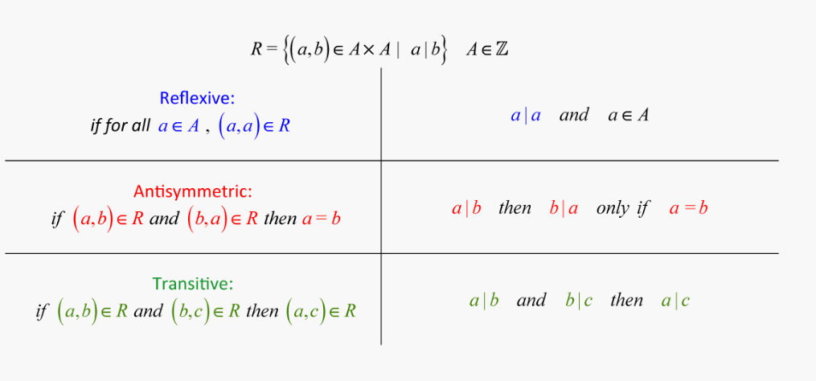

eBook Discrete Mathematics
https://old.amu.ac.in/emp/studym/100006299.pdf
LINKS: https://youtu.be/mKA2cdRexFk
https://youtu.be/VYcuDCUzfCU
https://youtu.be/MxT-NpCPqcY

